Name: Richard Raymond J. Canda

C.Y.S.: BSCpE - 3A

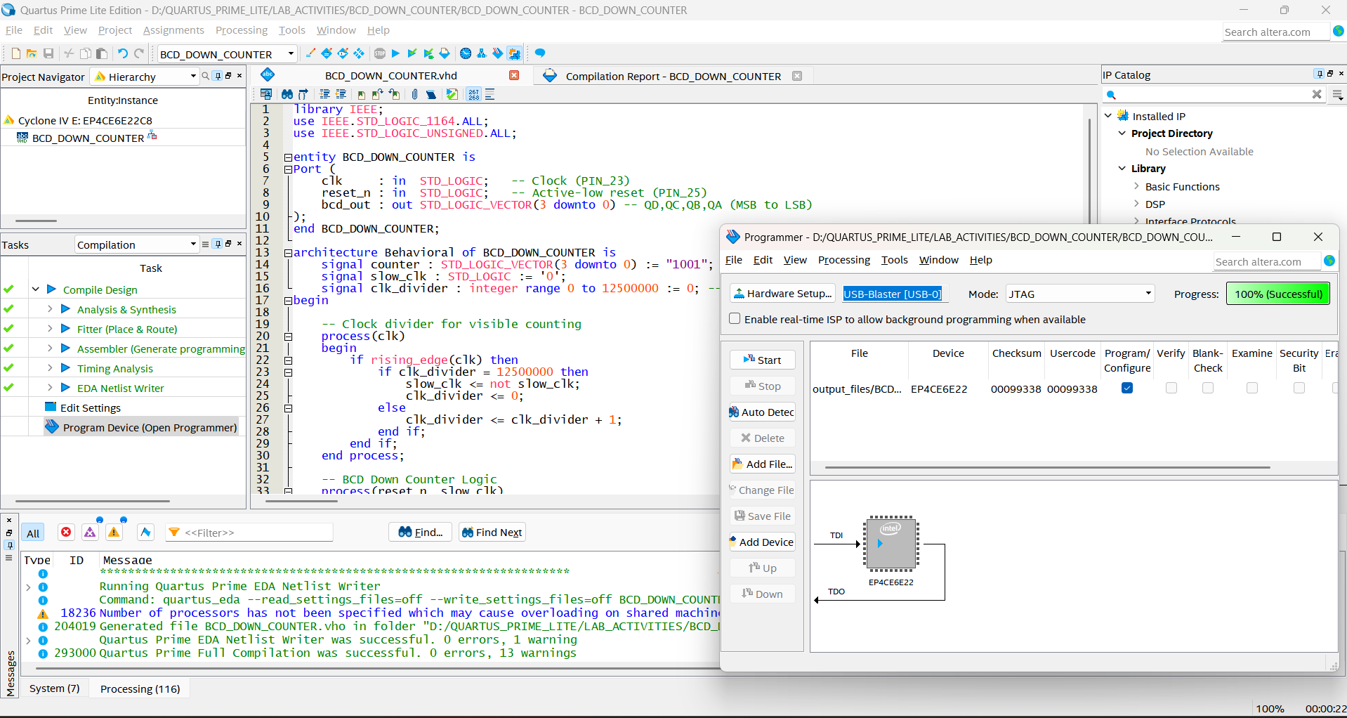

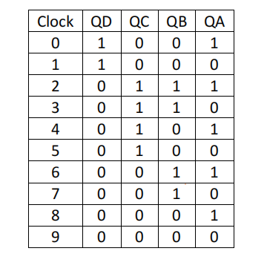

**BCD DOWN COUNTER:**

library IEEE;

use IEEE.STD_LOGIC_1164.ALL;

use IEEE.STD_LOGIC_UNSIGNED.ALL;

entity BCD_DOWN_COUNTER is

Port (

clk : in STD_LOGIC; -- Clock (PIN_23)

reset_n : in STD_LOGIC; -- Active-low reset (PIN_25)

bcd_out : out STD_LOGIC_VECTOR(3 downto 0) -- QD,QC,QB,QA (MSB to LSB)

);

end BCD_DOWN_COUNTER;

architecture Behavioral of BCD_DOWN_COUNTER is

signal counter : STD_LOGIC_VECTOR(3 downto 0) := "1001"; -- Start at 9

signal slow_clk : STD_LOGIC := '0';

signal clk_divider : integer range 0 to 12500000 := 0; -- 2Hz @ 50MHz

begin

-- Clock divider for visible counting

process(clk)

begin

if rising_edge(clk) then

if clk_divider = 12500000 then

slow_clk <= not slow_clk;

clk_divider <= 0;

else

clk_divider <= clk_divider + 1;

end if;

end if;

end process;

-- BCD Down Counter Logic

process(reset_n, slow_clk)

begin

if reset_n = '0' then

counter <= "1001"; -- Reset to 9

elsif rising_edge(slow_clk) then

if counter = "0000" then -- 0 in decimal

counter <= "1001"; -- Reset to 9

else

counter <= counter - 1; -- Decrement

end if;

end if;

end process;

-- Active-low LED output (0=LED ON, 1=LED OFF)

bcd_out <= not counter;

end Behavioral;